Real Time Based Solider Health Monitoring System Using GPS and GSM
S. Towseef Ahmed  Assistant Professor  at G.Pullaiah College of Engineering & Technology in Kurnool, India, Department of Electronics & Communication Engineering.  towseef.453@gmail.com | Muralidhar Reddy Bandi  UG Scholar  at G.Pullaiah College of Engineering and Technology in Kurnool, India, Department of Electronics and Communication Engineering.  muralidharreddybandi0772@gmail.com
NandaKrishna Yelamakuri  UG Scholar  at G.Pullaiah College of Engineering and Technology in Kurnool, India, Department of Electronics and Communication Engineering.  yelamakurinandakrishna@gmail.com | Raju Kashapogu  UG Scholar  at G.Pullaiah College of Engineering and Technology in Kurnool, India, Department of Electronics and Communication Engineering.  kanna9110@gmail.com

Abstract— Today's world, the security of country depends on the enemy's war, so the security of the army is also important. The nation's armed forces have Three services: army, army and army. Considering the safety of soldiers, many tools can check the health and ammunition of soldiers. To overcome security issues, we developed this project to include temperature, heart rate sensors, etc. that can monitor soldiers' health when necessary. We developed it using a network of wireless body area sensors. Using GPS, we can track the exact location of soldiers when necessary. These gadgets were added to guns, weapons and soldiers; For example, The Israeli Army is exploring the potential of having GPS devices on soldiers shirts , uniforms so that leaders in the region can instantly track the army's movements. Fast Transmission, short-range and effective military-to-military Wireless communications will be needed to transmit information related to surveillance-related situational awareness, decision-making, and data protection during special investigations and other operations. By using all these tools, we are trying to use simple defense systems for the army with low-cost, light, easy-to-carry, and sensitive equipment. In today's world, war is an crucial part of any nation's security. The army plays an important and important role. In our study, we revealed the idea of ​​tracking soldiers and ensuring their health during war, which enables soldiers to prepare war strategies. The base station can learn the location of the troops using the location sent by the GPS modem.

Keywords— Arduino Nano, temperature sensor, GSM, GPS, LCD, buzzer, pulse rate sensor, temperature sensor, Arduino IDE, onboard C

Introduction
The most important objective of this mission is to discover the precise position of the wounded soldiers on the battlefield. GSM-based military health and location monitoring system stores the place of the army based on latitude and longitude [1,2,3]. The LCD is linked to the Arduino to capture the received prior data sending it via GSM [4]. The military must cooperate with medical monitoring, continuous GPS (Global Positioning System), data exchange to send and receive data to control facilities [5, 6, 7]. It may be needed not only for soldiers to communicate remotely with the control center, but also for the control room of other soldiers. In addition to national security, the military also needs to ensure their health by ensuring the military's ability to perform well, and the organization must maintain checks on the authorities who manage military medicine [8, 9, 10].

To meet this need, bio-therapeutic sensors, and analysis tools are integrated into the operator in this paper. The composite material should be lightweight and provide the desired results without requiring too much energy. One of the main problems in the army is the unpreparedness of officers in talking to commanders [11, 12]. More importantly, the military's strategic approach plays a key role in careful planning and coordination. Therefore, operational plans focus on monitoring combat zones, which will be useful for the station control room to know the officer's watchful area and guide them if necessary yes. The control center uses GPS to locate the battle location [13, 14, 15]. When a soldier falls on the battlefield, the base station needs to point him in the right direction. This article will be beneficial for warriors participating in particular events or task. This jacket can detect heart rate sensors, temperature and humidity sensors, vibration sensors, explosives, etc.
It is equipped with a good electronic rear including [16, 17, 18]. These are deployed in the military for full portability. The framework will use remote connections to access the stations' servers. Data obtained from the base station can be used for more predictions [19, 20]. This allows the administration to take into account the conditions of the mandate. The security of the country is tracked and maintained by the Land, Navy and Air Forces. Soldiers who sacrifice their lives for their country perform the most important and important duty. There are several worries concerning the safety of soldiers. Soldiers who cross enemy lines often die due to lack of communication, and the military base station needs to know where each soldier is and what he is doing [21, 22]. India lost a high number of soldiers in the war due to a shortage of health support and communication among the soldiers in the battlefield and the leaders of their son's fat base station.
Hardware description:
Arduino Nano: Arduino Nano is a compact, full breadboard board powered by the ATmega328 (Arduino Nano 3.0) or ATmega168 (Arduino Nano 2.x). It has almost the similar functionality as Arduino Duemilanove, but in a different package. It just doesn't have a DC power supply and can use a Mini-B USB cord rather than a standard cable. Designed and manufactured by Nano Gravitech[23].
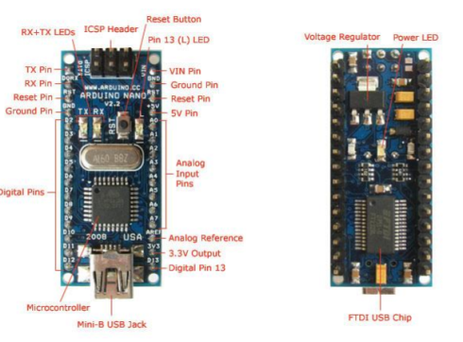

Fig.1: Ardunio Nano
LCD(liquid crystal display ):
An LCD (liquid crystal display) display is an electronic device with many uses. 16x2 LCD screen is a very simple model that is frequently used many devices and circuits[24].
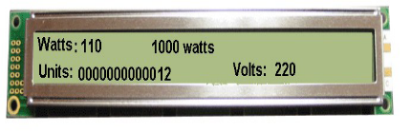

Fig.2:Liquid crystal display
GPS NEO6M:
GPS stands for Global Positioning System, where anyone can get location information anywhere in the world at any time. First, a time signal is sent to a specific location by the GPS satellite. The time difference between the GPS time and the time point at which the GPS receiver get the time signal is then computed to determine the distance between the receiver and the satellite. [25].
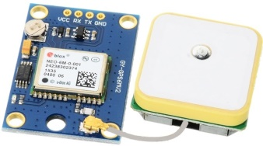

Fig.3: GPS NEO6M

GSM Module SIM 800L:
The Sim800L module is a low-cost, small GSM module built on Simcom's Sim800L chipset. This low cost is ideal for starting your next IoT project. You almost make it a phone with this mod. The main disadvantage of this module is that It runs on 3.7 to 4.2 volts, hence it cannot be powered directly. from Arduino or Raspberry Pi. Additionally, sim800L GSM and GPRS modules need up to two amps of Current, therefore design your power supply accordingly [26].
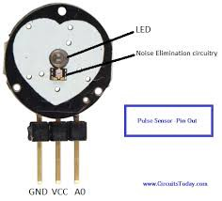

Fig.4: GSM Module SIM 800L

Pulse sensor:
Connect the heart rate sensor to Arduino. The pulse sensor contains three pins. Connect the 5 Volts and Ground pins of the pulse sensor to the 5V and ground pin of the Arduino and the signal pin to the A0 pin of the Arduino. A basic heart rate sensor consists of a light-emitting diode and a detector, such as a photodiode or light resistor. [27].

LM-35 Temperature Sensor:
The LM35 temperature sensor may be used to monitor temperature by comparing the fire exit temperature in degrees Celsius. It is more capable of measuring temperatures than the thermistor. This sensor delivers a greater output than a thermocouple and does not require an increase in output voltage. The scale factor is .01V/°[28].

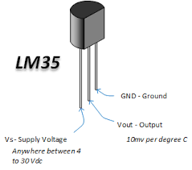

Fig.5: LM-35 Temperature Sensor

Methodology

Working process:

The most important objective of this mission is is to find the exact location of injured soldiers on the battlefield. GSM-based military health and location tracking system stores the location of the army based on latitude and longitude. This data is supplied into the Arduino, which is interfaced. with the GSM modem. Arduino collects exact position information from GPS and sends an SMS to the relevant organization via a GSM modem.
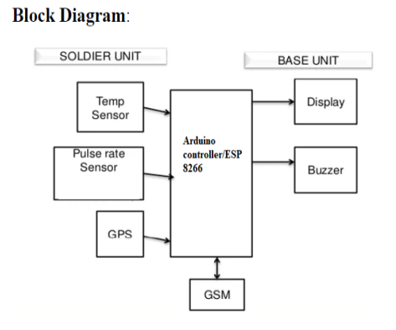

Fig.6: Representation of block diagram parts

1. Soldier's Health Monitoring Device: Each soldier is equipped with a wearable device that integrates various sensors and To monitors vital indications such as heart rate, body temperature, blood pressure. The device is also equipped with a GPS module to determine the soldier's location.

2. Data Collection: The Health monitoring device continuously collects the soldier's vital signs and GPS coordinates. It stores this information in its internal memory for further processing.

3. Data Transmission via GSM: At regular intervals or in real-time, the device establishes a connection with the GSM network. It uses the GSM module to transmit the collected data to a central server.

4. Central Server: The central server receives the transmitted data from multiple soldiers. It acts as a central hub for processing and analyzing the received information.

5. Data Processing and Analysis: The server employs sophisticated algorithms to process and analyze the received data. It identifies any abnormal readings or potential health risks based on predefined thresholds and medical guidelines.

6. Alert Generation: If the server detects any critical health issues or anomalies, it generates an alert. This alert is sent to authorized personnel, such as medical professionals or commanding officers, through various means like text messages, emails, or notifications on dedicated applications.

7. Visualization and Monitoring: The server provides a user-friendly interface that displays real-time health status and location information of individual soldiers. This allows authorized personnel to monitor the soldiers' well-being and make informed decisions.

8. Emergency Response: In case of emergencies or critical health situations, the system triggers an immediate response. This can involve dispatching medical teams to the soldier's location or providing necessary instructions to the soldier or nearby personnel.

The proposed system also incorporates a mobile application for soldiers, allowing them to view their health status and receive immediate feedback. This fosters individual health awareness and empowers soldiers to take preventive measures.
In conclusion, the real-time soldier health monitoring system with GPS and GSM integration offers a comprehensive solution for military operations. By leveraging wearable sensors, GPS technology, and real-time communication, this system ensures the well-being of soldiers is continuously monitored, providing critical information for timely decision-making and ultimately enhancing mission success.

Results
Result and Discussion:
The system starts with wearable health sensors attached to each soldier. These sensors continuously measure Vital indicators including heart rate, body temperature, and activity levels. Connected to each soldier, the GPS module tracks and records the precise location of individual soldiers in real time. The GPS data is a crucial aspect of the monitoring system, providing dynamic positioning information. The health sensors and GPS modules are linked to GSM communication modules. These modules enable wireless communication and data transmission using the GSM network. The GSM network facilitates communication with a mobile application on each soldier's device. The application serves as an interface, allowing soldiers to view their real-time health status and receive immediate feedback. The GSM network connects the soldier's wearable sensors, GPS modules, and mobile applications to a centralized command and control center. This central hub acts as a receiver for all incoming data from the soldiers in the field. The centralized command center is linked to a backend server. The server manages the storage, processing, and analysis of the incoming health and location data from all soldiers. Visualization tools are connected to the backend server, presenting processed data in an understandable format. Commanders Can check the health and locations of soldiers through these tools. An alert system is integrated into the backend server. In the event of emergencies or abnormal health conditions, the system triggers alerts to notify commanders for immediate attention.

The final outcome is displayed below. A message is delivered to the registered phone number, verifying GSM and GPS settings. Later, when the typical bodily parameters diverge, an alarm message is transmitted to the base station, coupled with the soldier's specific position.
The following conclusions may be derived from the above implementations:
• Soldiers' Security and safety: GPS records soldiers' positions anywhere on the planet, and a health system analyzes soldiers' key health factors as well as the surroundings, providing soldiers with protection and safety.
• Less complicated circuit and lower power consumption: The use of a PIC processor and low-power peripherals reduces the overall power consumption of the system. The modules utilized are compact and lightweight, making them portable.
• So in this way, the notion of tracking and navigation systems is extremely beneficial for warriors when they are in the military field during war. And also for base stations So that they may obtain real-time views of soldiers.

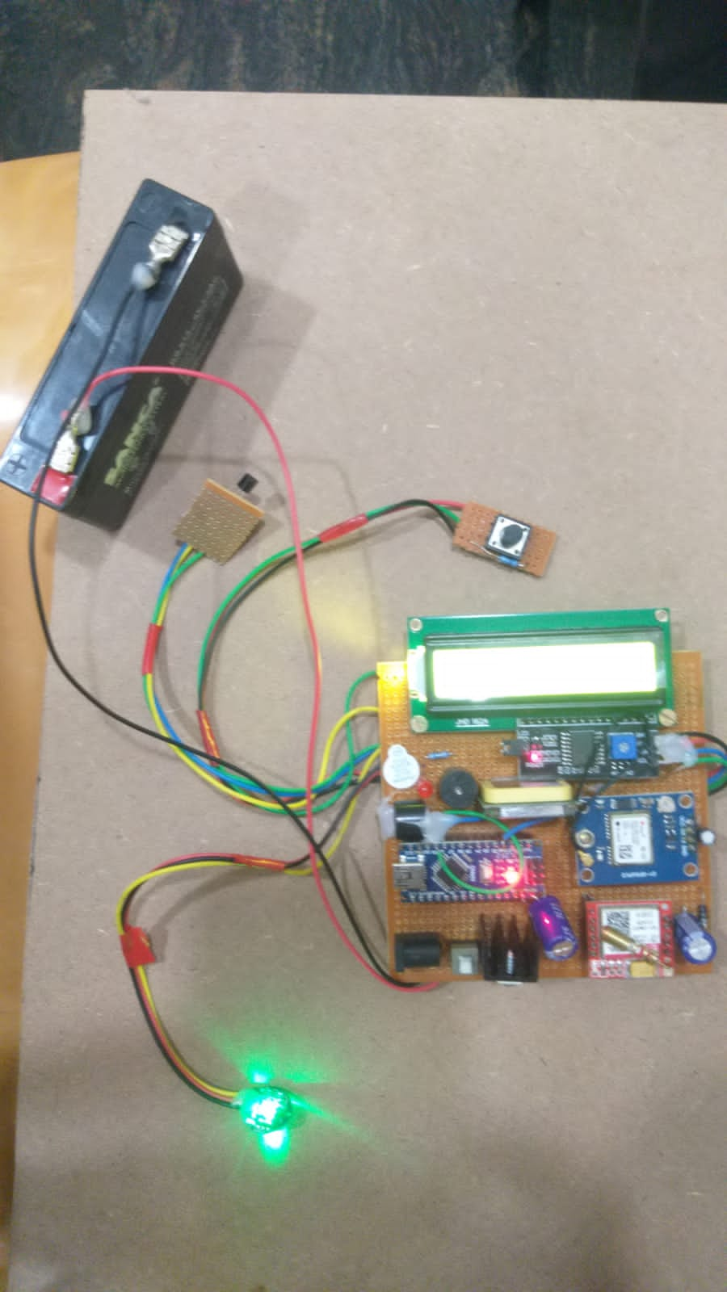
Fig.7 Architecture representation as per block diagram

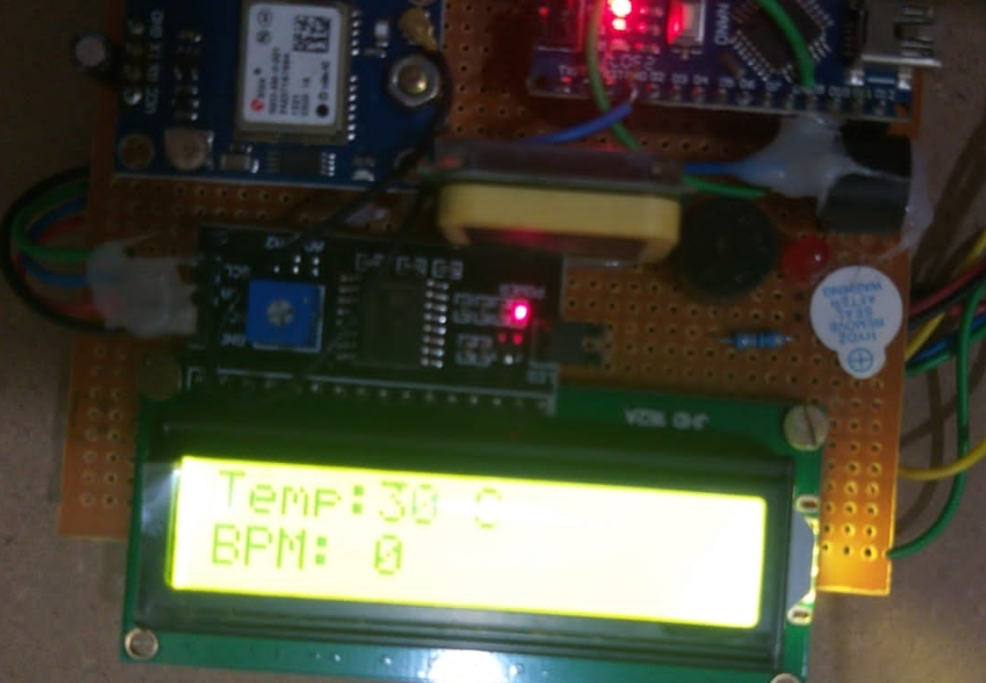 | 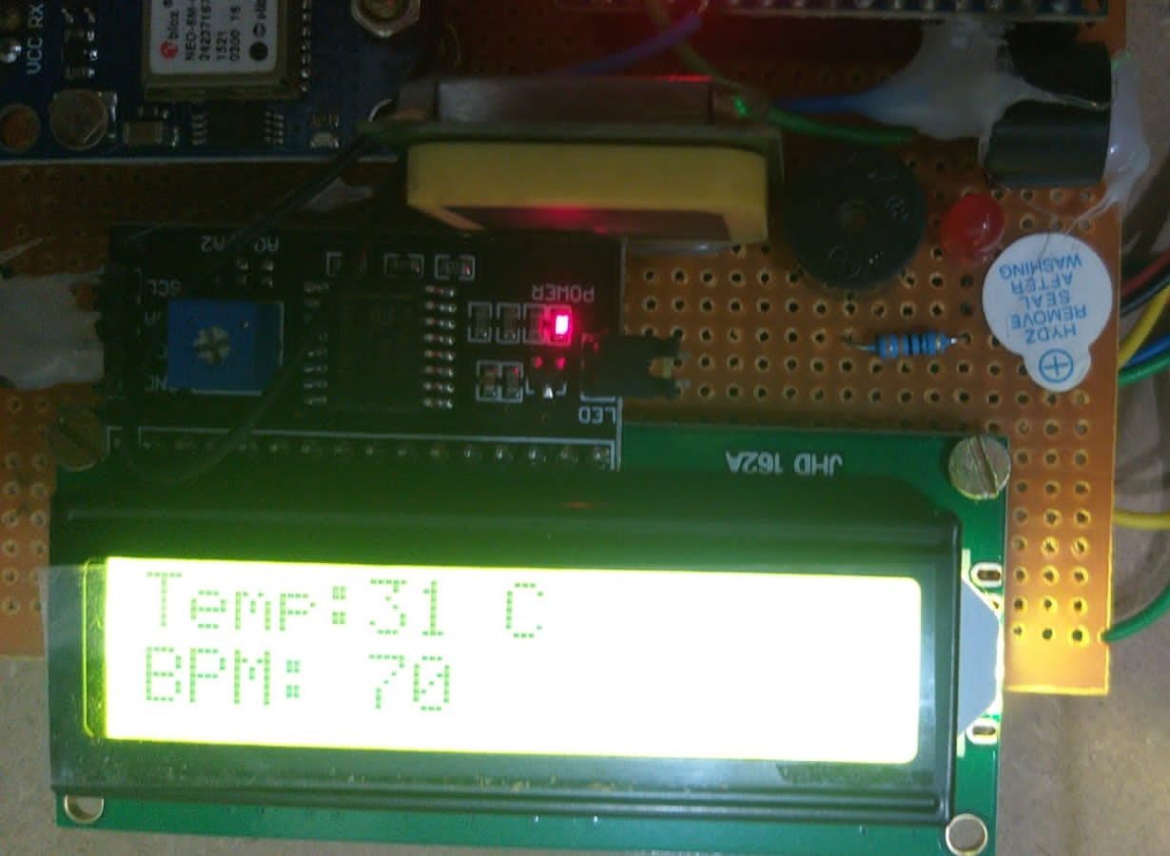
Fig.8:Displaying various results

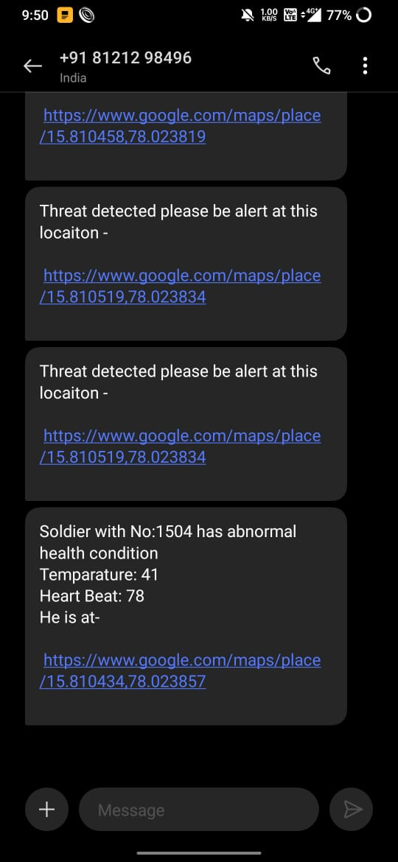

Fig.9:Displaying final output in mobile through text message

Conclusion
The Army Healthcare and Location Tracking GPS program is a key safety and protection feature that combines electronic and wireless automation. We conclude that the above system is used to monitor the physical health of soldiers using the heart rate sensor, temperature sensor, pressure sensor and oxygen sensor. This method is also useful for soldiers in war because if they think they are in a critical situation, they can ask for help from the base station by pressing the button on the base station. Our scheme also sends Details about the location and intent of the SMS to the base station. Our plan will provide greater security for our warriors by connecting the gas detector to the appropriate sensor station. Interconnecting a camera to the controller might also help in this procedure. Once the above process is completed, it will help determine the health of soldiers by measuring heart rate and body temperature. It will also help in tracking its location using a GPS Modem and through a GSM Modem it will be able to send all the data to the base station for further processing.

References
- Hock Beng Lim, Di Ma, Bang Wang, Zbigniew Kalbarczyk, Ravishankar K. Iyer, Kenneth L. Watkin (2010) “A Soldier Health Monitoring System for Military Applications” International Conference on Body Sensor Networks, pp: (246-249).
- William Walker, A. L. Praveen Aroul, Dinesh Bhatia (2009) “Mobile Health Monitoring Systems” 31st Annual International Conference of the IEEE EMBS, Minneapolis, Minnesota, USA, pp: (5199-5202).
- M. Pranav Sailesh, C. Vimal Kumar, B. Cecil, B. M. Mangal Deep, P. Sivraj (2014) “Smart Soldier Assistance using WSN” International Conference on Embedded Systems - (ICES 2014), IEEE, pp: (244-249).
- P.S. Kurhe, S.S. Agrawal (2013) “Real Time Tracking and Health Monitoring System of Remote Soldier Using ARM 7”, International Journal of Engineering Trends and Technology, 4(3), pp: (311-315).
- Shruti Nikam, Supriya Patil, Prajkta Powar, V. S. Bendre (2013) “GPS Based Soldier Tracking and Health Indication System” International Journal of Advanced Research in Electrical, Electronics and Instrumentation Engineering, 2(3), pp: (1082-1088).
- Prof. Pravin Wararkar, Sawan Mahajan, Ashu Mahajan, Arijit Banerjee, Anchal Madankar, Ashish Sontakke (2013) “Soldier Tracking and Health Monitoring System” The International Journal of Computer Science & Applications, 2(02), pp: (81-86).
- Govindaraj A., Dr. S. Sindhuja Banu (2013) “GPS Based Soldier Tracking and Health Indication System with Environmental Analysis”, International Journal of Enhanced Research in Science Technology & Engineering, 2(12), pp: (46-52).
- Palve Pramod, “GPS Based Advanced Soldier Tracking With Emergency Messages & Communication System” (2014) International Journal of Advance Research in Computer Science and Management Studies, 2(6), pp: (25-32).
- Mr. Rajdeep Limbu, Prof. V. V. Kale (2014) “GPS Based Soldier Tracking and Health Monitoring System” International Journal for Technological Research in Engineering, 1(12), pp: (1485- 1488).
K.C.T. Swamy, D. Venkata Ratnam and Towseef Ahmed Shaik, "Double difference method with zero and short base length carrier phase measurements for Navigation with Indian Constellation satellites L5 (1176.45 MHz) signal quality analysis", Int. J. Satell. Commun. Networking, vol. 40, no. 4, pp. 294-304, 2022.
- Simon L. Cotton and William G. Scanlon ―Millimeter - wave Soldier –to soldier communications for covert battlefield operations Defence science and technology laboratory, IEEE communication Magzin October 2009.
- Hock Beng Lim “A Soldier Health Monitoring System for Military Applications‖ 2010 International Conference on Body Sensor Networks (BSN).
- JouniRantakoko,JoakimRydell and peter Stromback,‖Accurate and Realiable soldier and first responder Poasitioning :Multisensor System and co-operative localization‖April-2011.
- K.C.T Swamy, A. D Sarma, A Supraja Reddy, Analysis of Ionosphere scintillation of GPS and VHF/UHF signals over low latitude Indian region, Information and communi-cation Technologies (WICT), 2012 World Congress, IEEE, 2012.
- Vincent Pereira, Audrey Giremus,andericgrivel ―Modeling of the multipath environment using copulas For particle filtering based GPS navigation‖ June-2012.
- M.V.N.R. Pavan Kumar1, Ghadge Rasika Vijay2, PatilVidya Adhikrao3, Bobade Sonali Vijaykumar4 Department of Electronics and Telecommunication Engineering 1,2,3,4, LNBCIET, Satara-415020 1,2,3,4Health Monitoring and Tracking of Soldier Using GPS.
- Arya V Nair, Rani Raju, Tinsa Elsa Thomas and Vidya R Nair, “IoT Based Soldier Monitoring System”, Pramana Research Journal, Volume No:9, Issue:5, pp: 157-165,2019.
- Brijesh Iyer and Niket Patil, “IoT enabled tracking and monitoring sensor for military applications”, International Journal of Systems Assurance Engineering and Management, SPRINGER, July-2018.
- D. Poornakumar, R. Periyanayaki, M. R. Pradheepa, N. Prakashkumar, and S. Nandhini, “Soldiers Navigation and Health Monitoring System using GPS and GSM”, International Journal of Research in Engineering Science and Management, Volume No: 3, Issue:4,pp:115-158, April-2020.
- Deepa J, Ranjini, Sharanya Raj and Dr.Parameshachari B D, “Soldier Health Positioning Tracking System Using GPS and GSM Modem”, International Journal of Engineering Research& Technology (IJERT),pp:1-6,2018.
- Dineshwar Jaiswar and Sanjana S. Repal, “Real-Time Tracking and Health Monitoring of Soldier using ZigBee Technology”, International Journal of Innovative Research in Science, Engineering, and Technology: a Survey, Volume No:4, Issue:7, pp: 5560-5574, July-2015.
- E. J. Shanko and M. G. Papoutsidakis, “Real-time health monitoring and wireless transmission: A μController application to improve human medical needs”, 2013 E-Health and Bioengineering Conference (EHB), Isai,pp:242-249,2013.
- Pranava Madan1, Lakshay Dhama, Rajiv Dahiya, Ruchika Doda, A Review Paper on Arduino Research Papers, International Journal for Research in Applied Science & Engineering Technology (IJRASET) ISSN: 2321-9653; IC Value: 45.98; SJ Volume 7 Issue III, Mar 2019- Available at www.ijraset.com
- Shunsuke KOBAYASHI,corresponding author, Tomohiro MIYAMA, Hidenari AKIYAMA and Atsushi IKEMURA, Development of liquid crystal displays and related improvements to their performances. Proc Jpn Acad Ser B Phys Biol Sci. 2022 Nov 11; 98(9): 493–516.
- Garla Ramesh, IoT Based GPS Location Tracker Using NodeMCU and GPS Module.IJSART - Volume 7 Issue 5 – MAY 2021.
- Oyebola Blessed Olalekan, Development of a Sim800l Based Reprogrammable Household Smart Security System with Recipient Phone Call Alert. IJCERT Volume 4.Issue 1, January 2017.
- Vani S Indrali, Development of Pulse Rate Indicator in Real Time .IJERT ISSN: 2278-0181 Published by, www.ijert.org IETE – 2020 Conference Proceedings.
- Deepak. S. Kumbhar, Harish. C. Chaudhari ,Temperature Monitoring to Study Concrete Maturity in Civil Structure.JETIR May 2019, Volume 6, Issue 5.

